# ***MOBILE APP DEVELOPMENET LAB***

# ***Week 10***

Program: Design an android application for bottom navigation menu

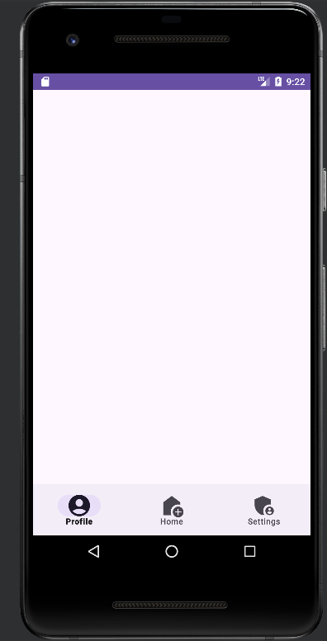  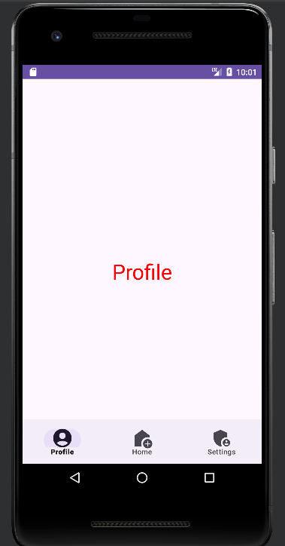

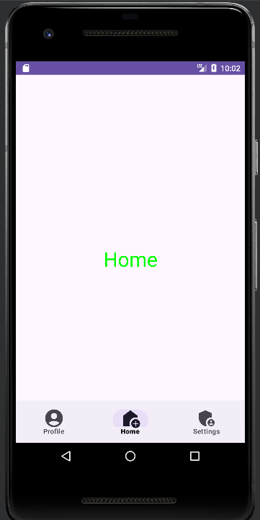  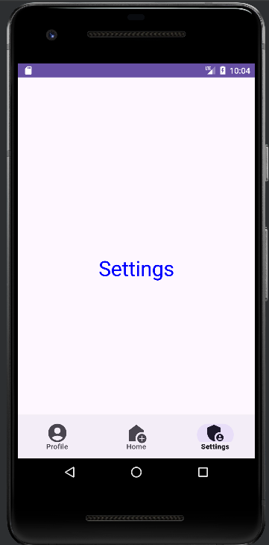

**Create android resource directory** -right click on res🡪new🡪Android resource directory

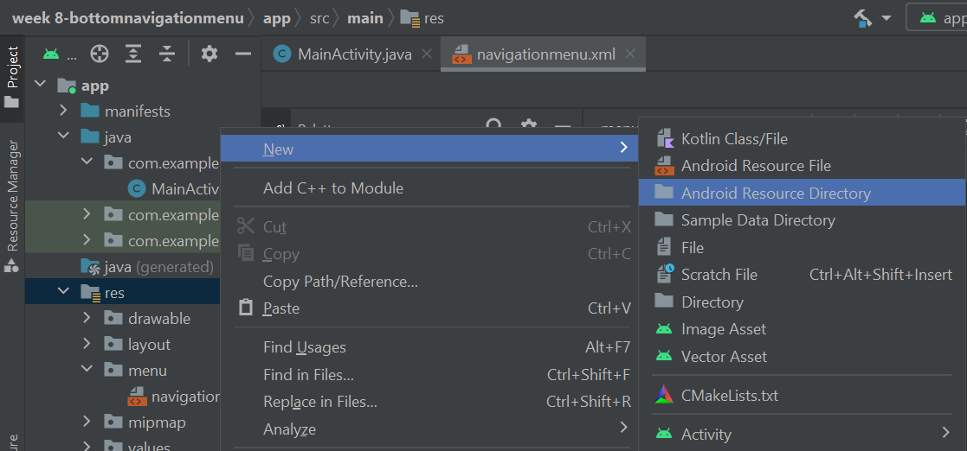

In resource type select menu

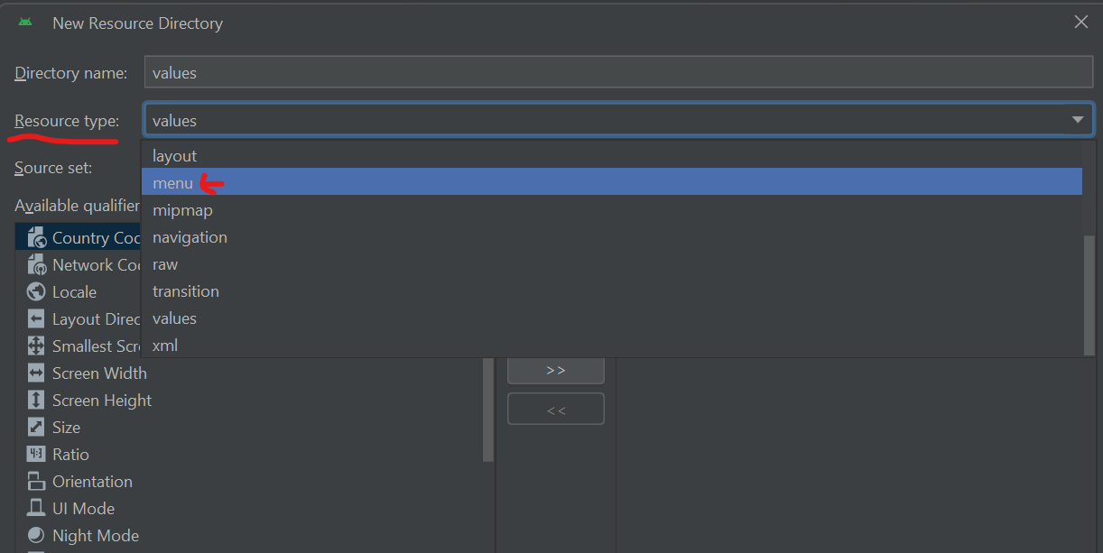

Menu folder will appear in the res directory

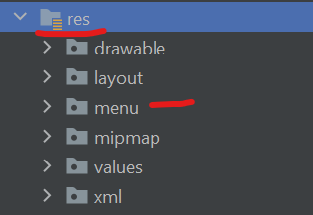

Create menu Resource file

Right click on Menu 🡪New 🡪 Menu Resource File

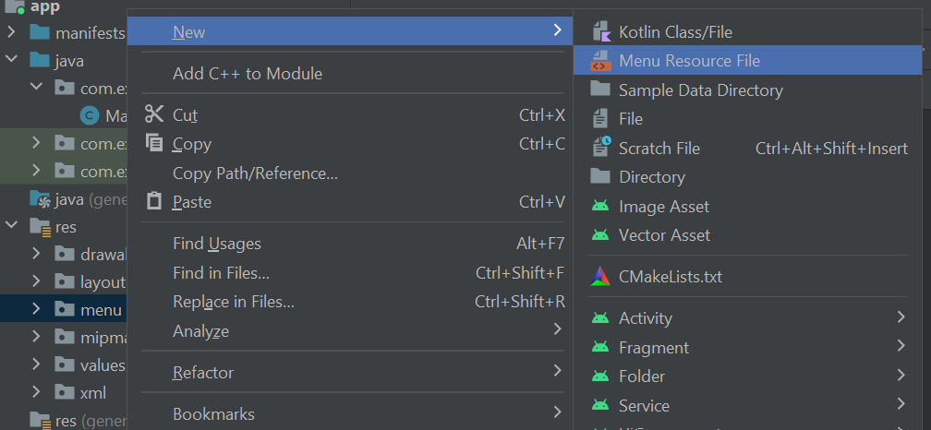

Name it navigationmenu

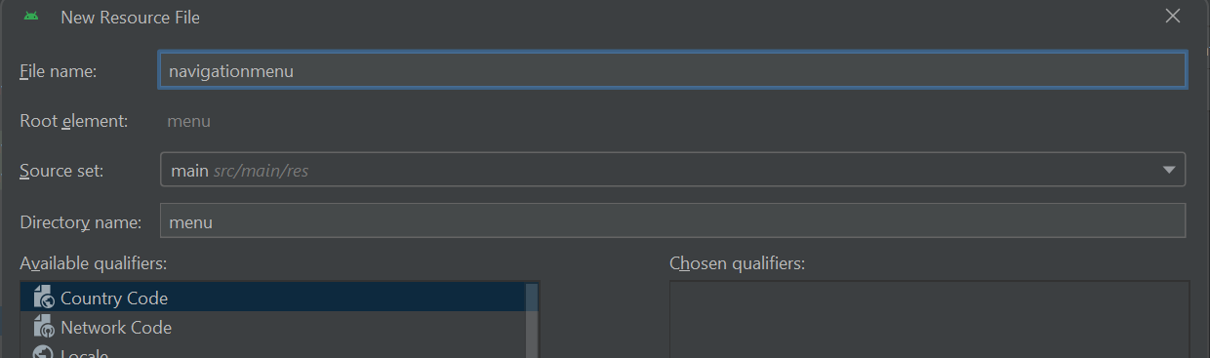

**Create icons**

Right click on Drawables🡪 New🡪 vector asset🡪clip art

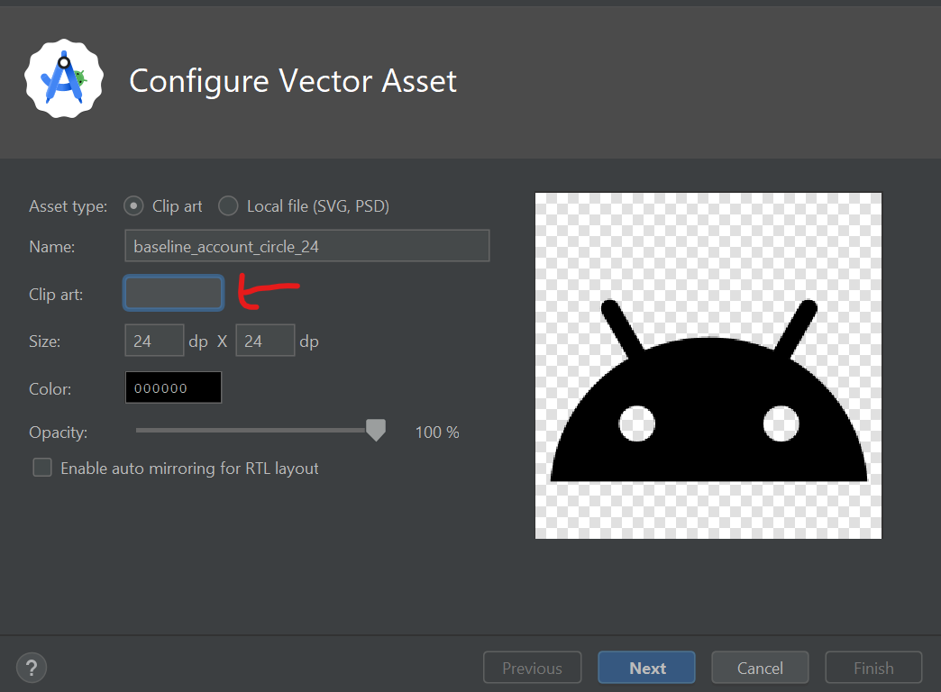

Search for home and select an icon

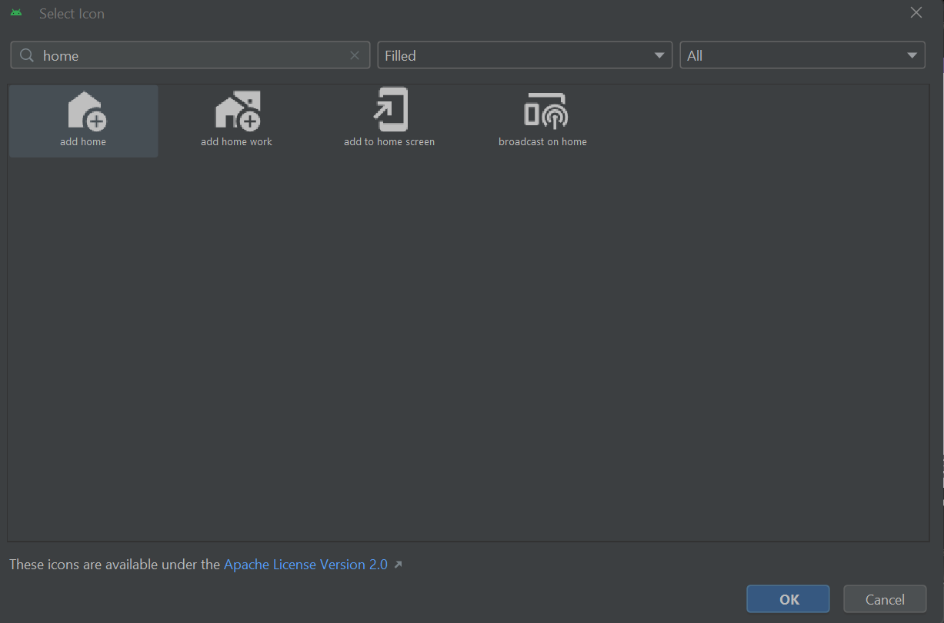

Right click on Drawables🡪 New🡪 vector asset🡪clip art

Search for account

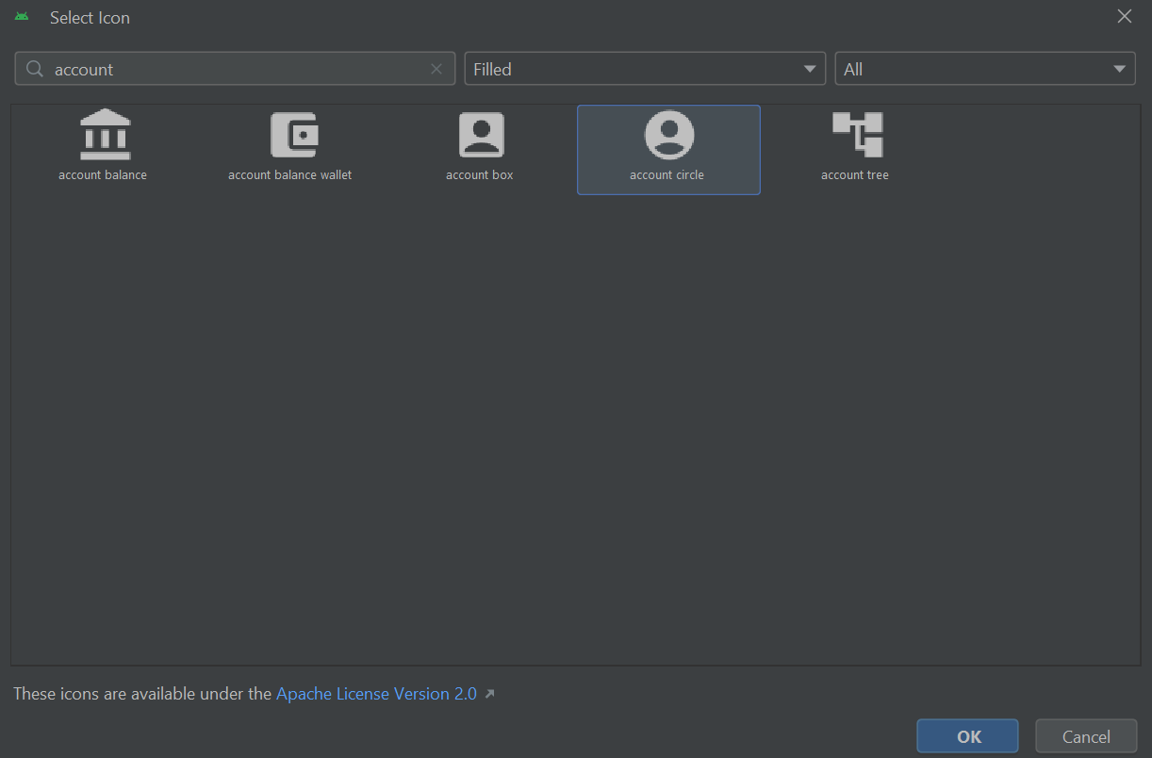

Right click on Drawables🡪 New🡪 vector asset🡪clip art

Search for settings

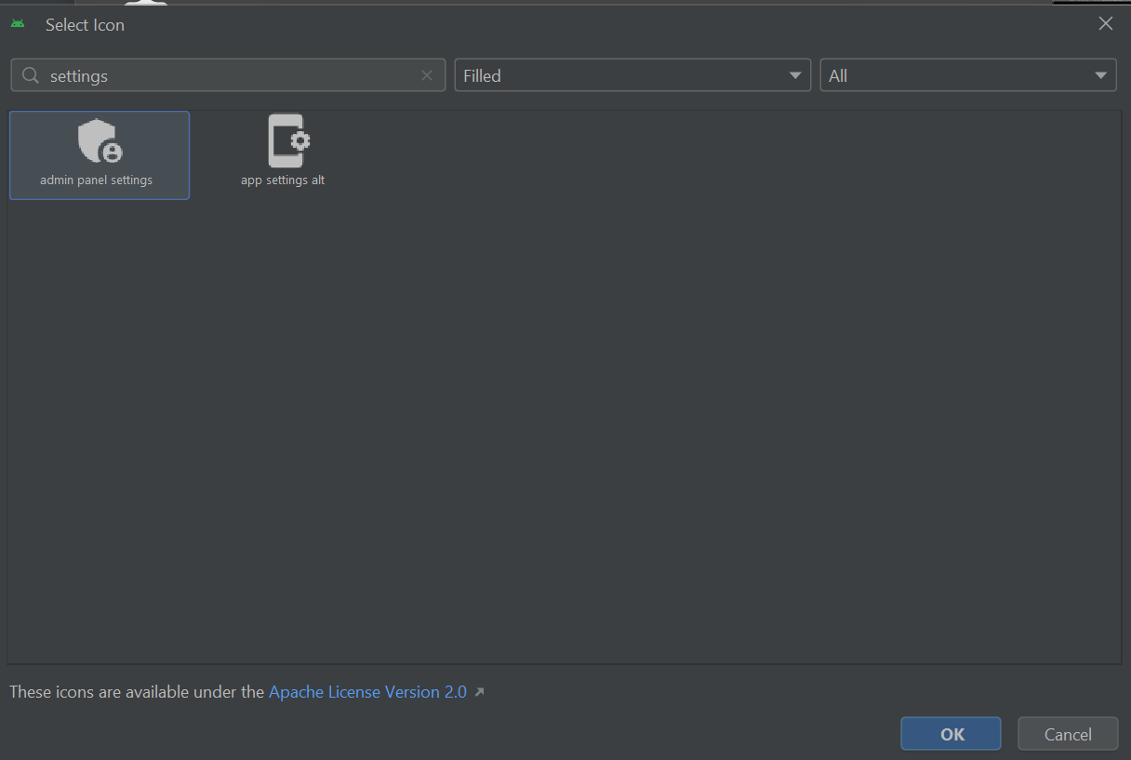

navigationmenu.xml

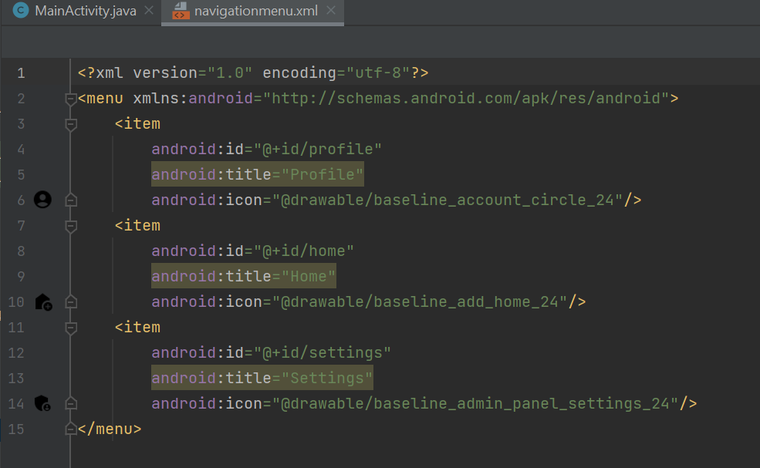

Res🡪values🡪colors.xml

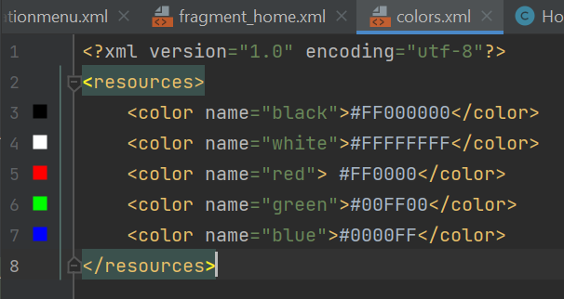

Create 3 fragments named Home,Profile Settings

Fragment_home.xml

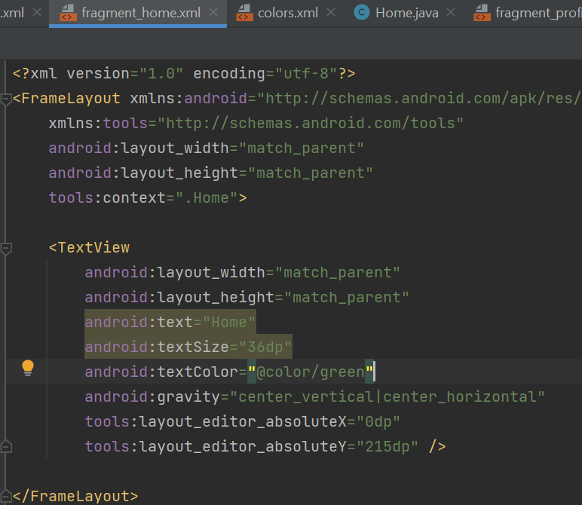

Fragment_profile.xml

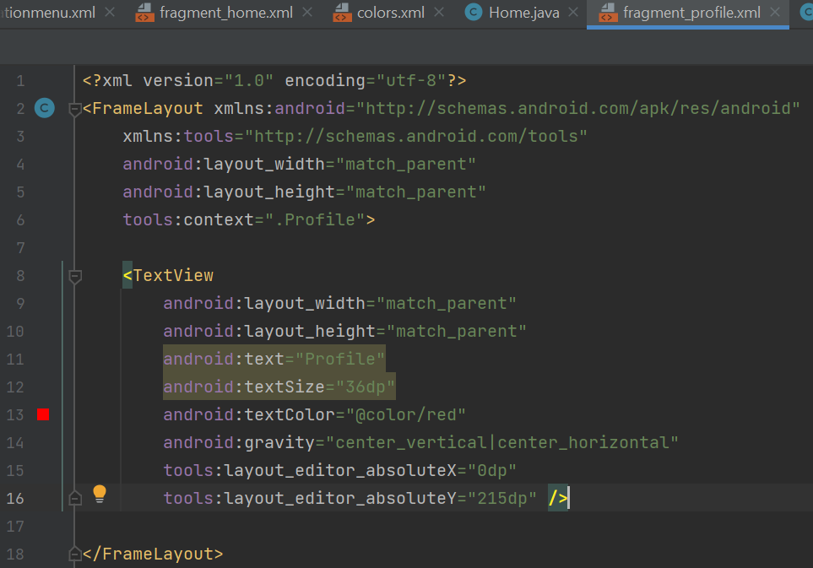

fragment_settings.xml

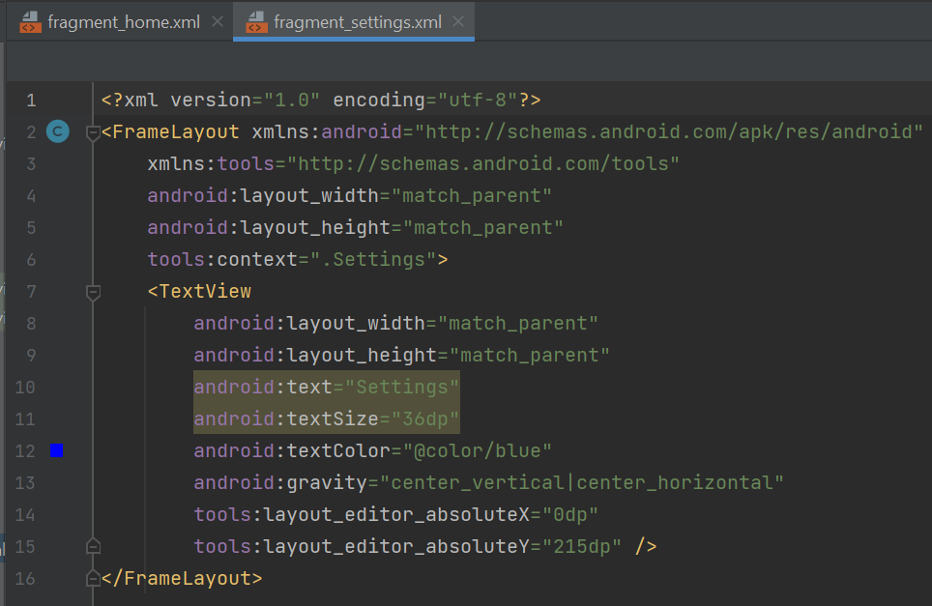

Activity_main.xml

<?xml version="1.0" encoding="utf-8"?>  
<androidx.constraintlayout.widget.ConstraintLayout xmlns:android="http://schemas.android.com/apk/res/android"  
 xmlns:app="http://schemas.android.com/apk/res-auto"  
 xmlns:tools="http://schemas.android.com/tools"  
 android:layout_width="match_parent"  
 android:layout_height="match_parent"  
 tools:context=".MainActivity">  
  
 <com.google.android.material.bottomnavigation.BottomNavigationView  
 android:id="@+id/bottomNavigationView"  
 android:layout_width="match_parent"  
 android:layout_height="75dp"  
 app:menu="@menu/navigationmenu"  
 app:layout_constraintBottom_toBottomOf="parent"  
 app:itemIconSize="38dp"  
 tools:layout_editor_absoluteX="1dp" />  
  
 <FrameLayout  
 android:id="@+id/fragmentView"  
 android:layout_width="match_parent"  
 android:layout_height="match_parent"  
 app:layout_constraintBottom_toTopOf="@+id/bottomNavigationView"  
 app:layout_constraintStart_toStartOf="parent"  
 app:layout_constraintTop_toTopOf="parent"  
 app:layout_constraintVertical_bias="1.0">  
  
 </FrameLayout>  
  
</androidx.constraintlayout.widget.ConstraintLayout>

MainActivity.java

package com.example.bottomnavigationmenu;  
  
import androidx.annotation.NonNull;  
import androidx.appcompat.app.AppCompatActivity;  
import androidx.fragment.app.Fragment;  
import androidx.fragment.app.FragmentTransaction;  
  
import android.os.Bundle;  
import android.view.MenuItem;  
  
import com.google.android.material.bottomnavigation.BottomNavigationView;  
import com.google.android.material.navigation.NavigationBarView;  
  
public class MainActivity extends AppCompatActivity {  
 BottomNavigationView bottomNavigationView;  
 @Override  
 protected void onCreate(Bundle savedInstanceState) {  
 super.onCreate(savedInstanceState);  
 setContentView(R.layout.*activity_main*);  
 bottomNavigationView = findViewById(R.id.*bottomNavigationView*);  
 openFragment(new Profile());  
 bottomNavigationView.setOnItemSelectedListener(new NavigationBarView.OnItemSelectedListener() {  
 @Override  
 public boolean onNavigationItemSelected(@NonNull MenuItem item) {  
 int itemId = item.getItemId();  
 if (itemId == R.id.*profile*) {  
 openFragment(new Profile());  
 } else if (itemId == R.id.*home*) {  
 openFragment(new Home());  
 } else if (itemId == R.id.*settings*) {  
 openFragment(new Settings());  
 }  
 return true;  
 }  
 });  
 }  
 private void openFragment(Fragment fragment) {  
 FragmentTransaction transaction = getSupportFragmentManager().beginTransaction();  
 transaction.replace(R.id.*fragmentView*, fragment);  
 transaction.addToBackStack(null);  
 transaction.commit();  
 }  
}